jmcintyre957

A QUestion of sport

Contents

Chapter 1 – Problem definition, investigation and analysis………………………………………………………………2

1. - Introduction…………………………………………………………………..………………………………………………………..2
   1. - Analysis of current system……………………………………………………………………………………………………….3
   2. - Information Gathering…………………………………………………………………………………………………………....4
   3. - User requirements…………………………………………………………………………………………………………………..4
   4. - Hardware and Software Requirements……………………………………………………………………………..…….5

Chapter 2 – Design……………………………………………………………………………………………………………………………6

2.0 - Design objectives……………………………………………………………………………………………………………………...6

2.1 - Proposed screen designs…………………………………………………………………………………………………………..7

2.2 - Proposed screen designs interviews ……………………………………………………………………………………….14

2.3 - Final screen designs…………………………………………………………………………………………………………………15

Chapter 3 – Testing strategy…………………………………………………………………………………………………..………30

3.0 - Test plan………………………………………………………………………………………………………………………………...30

3.1 - Test results……………………………………………………………………………………………………………………………..35

Chapter 4 – Evaluation………………………………………………………………………………………………………………..….52

4.0 - Evaluation of design objectives ……………………………………………………………………………………………...52

4.1 - Positive aspects of the system…………………………………………………………………………………………………55

4.2 - Future enhancements……………………………………………………………………………………………………………..55

4.3 - Evaluation of my performance …………………………………………………………………………………………….…56

Chapter 1 – Problem definition, investigation and analysis

1.0 - Introduction

Loreto College Coleraine is a mixed religion school situated on the Castlerock road, in Coleraine, County Derry. It educates both boys and girls between the ages of 11 and 18. Overall, Loreto is a high performing school, which was notably recognised in 2007, when the school was awarded [specialist school](https://en.wikipedia.org/wiki/Specialist_school) status for science. In 2018, the college was ranked 4th out of 192 schools in Northern Ireland in its A-level exam performance with 92.3% of entrants being awarded A*-C grades. In 2018 it was also ranked 12th in Northern Ireland for its GCSE performance with 99.2% of its entrants receiving five or more GCSEs at grades A* to C, including the core subjects English and Maths.

One of the factors that allows Loreto to achieve such good grades is the excellent facilities on the school campus. The perfect example of this is the 4 computer suites situated around the school, that all students have access to. Teachers aim to use these computers to fully maximise the interaction of pupils and their work. However, with the rise of computer games, such as Fortnite and Call of Duty, children are becoming more and more suited to learning through interactive and stimulating methods online.

I have therefore been asked by Mr. McCloskey of the PE department to create a fun, engaging quiz that tests the knowledge of year 11 pupils on various sporting topics. This quiz will allow pupils to further develop their ICT skills, while giving the teachers a good benchmark as to how well the pupils understand current sports events and recognise famous athletes around the world.

Recently, the PE department came to the realisation that the textbooks used in class are not engaging their pupils enough. This is subsequently causing a fall in overall grades, and idleness in class. The textbooks currently used are outdated and are not relevant to sports in today’s world.

In order to make up a list of what the quiz should entail, I will be participating in an interview with Mr. McCloskey, one of the PE teachers in Loreto. In this interview I will be identifying the areas as to which the quiz should focus on, as well as the requirements the quiz should follow to be a success. I will collect this information through a questionnaire.

1.1 - Analysis of current system

The method of teaching currently used by Mr. McCloskey and the rest of the PE department comprises of him and his pupils reading each topic from the textbook, and then making notes and answering questions for homework, due for the next class. A test is then set once a topic has been completed.

However, the issuing homework is one of the various flaws in this process. First of all, it is extremely easy for pupils of the same class to copy each other’s homework, as they are all doing the same questions. What’s more, with most questions set by teachers, the answers are in the textbook and can be copied word for word, with no thinking required by the pupils. This therefore means that with every end of topic test, pupils are underprepared and achieve low marks. Mr. McCloskey must then waste even more time marking correcting tests, and possibly even redoing certain topics of the subject.

The flow chart below shows the current process of teaching.

1.2 – Information gathering

In order to gather the information that Mr. McCloskey requires of the quiz, I shall make a questionnaire for him to complete. Questionnaires are beneficial in this case for numerous reasons. First of all, it is an economical way of accumulating information. Second of all, it is easy to plan, construct and distribute to anyone you wish to complete it. The questionnaire I created and gave to Mr. McCloskey is included at the end of this document.

1.3 – User requirements

After reviewing the questionnaire given to Mr. McCloskey, I have come up with a list of user requirements, which are as follows:

1. The quiz should include a loading screen.
2. The quiz must be designed for the 4-5th year group.
3. The pupils must answer the questions using a mixture of text boxes, multiple choice, and click and drag.
4. There should be 30-40 questions.
5. The pupils current score should be displayed on-screen.
6. The quiz’s theme should feature one constant colour.
7. The quiz should include a main menu.
8. The quiz should include a button to skip the current question.
9. The pupils should each have their own log-in information.
10. The quiz should have a leader board.
11. The quiz should not be case sensitive.
12. The quiz should include an introduction page before each question.
13. The quiz should include both gifs and pictures.
14. The pictures and gifs should be in various positions.
15. The pupils should interact with the quiz using a keyboard and mouse.
16. The quiz should include music, with the option to mute, and change the music.
17. The scores should be recorded at the end.
18. The score should be shown as a score out of the total marks available.
19. The pupil should be informed when they’ve answered a question wrong.
20. The pupil should be informed when they’ve logged on.
21. The quiz should include a help button for each question.
22. The questions should be asked in a random order.

1.4 - Hardware and Software Requirements

|  |  |
| --- | --- |
| Hardware | Explanation |
| Mouse | To navigate and select different elements of the program. |
| Keyboard | To enter answers into the program, and to interact with the PC to create the quiz itself. |
| A C2K Specification Windows PC | To create, and then run the program once finished. |

|  |  |
| --- | --- |
| Software | Explanation |
| OS - Windows XP or later | To navigate and select different elements of the program. |
| Microsoft Visual Studio | To enter answers into the program, and to interact with the PC to create the quiz itself. |
| .NET framework 4.0 or later | To create, and then run the program once finished. |

Chapter 2 – Design

2.0- Design objectives

|  |  |  |
| --- | --- | --- |
|  | **User requirements** | **Design objectives** |
| 1 | The quiz should have a loading screen. | I will create a loading screen which will appear when the program has begun. |
| 2 | The quiz should be for the 4th and 5th year groups. | It should be able to be easily answered by 4th and 5th years. |
| 3 | System quiz use text boxes, multiple choice, and click and drag answering techniques. | I will create questions that use each of these answering techniques. |
| 4 | The quiz should include 30-40 questions. | I will create 30-40 questions. |
| 5 | The users current score should be displayed on screen. | I will create a score counter, which will display their current score. |
| 6 | The quiz’s theme should use one constant colours. | I will use the same colour for each page. |
| 7 | The quiz should include a main menu. | I will create a main menu which will allow the user to log on with their own account. |
| 8 | The quiz should include a button to skip the current question. | I will include a button which allows the user to move onto the next question, if they are stuck. |
| 9 | Each user should have their own log-in information. | I will allow users to create an account if they do not have one already. |
| 10 | The quiz should include a leader board. | The quiz will include a leader board which is displays the users best score at the end of the quiz. |
| 11 | The quiz should not be case sensitive. | Questions can be answered in lower or upper case letters. |
| 12 | The quiz should include an introduction page before each section. | An introduction page will be included, which will show the user how to answer the questions for that section. |
| 13 | The quiz should include both gif’s and pictures. | Pictures will be used for the actual questions, while Gifs will be used on the introduction pages for each section. |
| 14 | The pictures and gifs should be in various positions. | The Gifs will be placed in the centre of the page, while pictures will be positioned in various places. |
| 15 | The user should interact with the quiz using a keyboard and mouse. | Questions will rotate between answers that should be entered through typing, and answers that are entered using a mouse. |
| 16 | The quiz should include music, with a choice of songs and to mute. | A music player construct will be included on the menu page, which allows the user to select a song, or mute the music completely. |
| 17 | The users score should be recorded at the end. | A leader board at the end of the game will display the users score. |
| 18 | The score should be shown as a score out of the total marks available. | The users score will be displayed as a scour out of 38 on the leader board. |
| 19 | The user should be informed if they’ve answered a question wrong. | A message box will appear, telling the user that they have answered the question incorrectly. |
| 20 | The pupil should be informed they’ve logged on successfully. | I will create a system that notifies the user when they log on with correct details. |
| 21 | The quiz should include a help button for each question. | A button will be included on each question, which will give the user help. |
| 22 | The questions should be asked in random order. | In each section, the questions will appear in a random order each time. |

2.1- Proposed screen designs

Proposed interface 1:

Progress bar

Question of sport logo

This is the proposed interface of the splash screen that which will be the first screen the user is presented with upon launching the program. This screen will feature the “Question of sport” logo in the background. The continuous progress bar will be linked to a timer, and will move from left to right, for a set period of time. Once the timer is up, the program will launch the next page. Throughout this process, the user will be unable to interact with any element of the screen.

Proposed interface 2:

Username

Register/Sign up

Password

Confirm Password

Log In

This concept shows the proposed interface for the main menu and log in screen. If the user does not yet have an account, it allows them to register and create an account. If the user enters correct log in details, the next screen will load. If the user’s details are incorrect, the program will notify them with a pop-up box, and then ask them to enter again.

Proposed interface 3:

Guess the player

ROUND ONE

Continue

[GIF]

[Text Box]

Proposed interface 4:

This page will be displayed on screen after the user logs in. A Gif will be situated in the middle, and displays an image related to the proceeding section, which is football. Underneath, information on how to answer the questions will be given. Once the user has read the instructions, they will press continue, which will bring them to the next screen.

Help

Score Counter

Name this player:

[Picture of player with face blurred out]

Continue

[Text Box]

Confirm

This interface includes a picture of a football player, but their face has been blurred out. The user must then input the correct name of the player into the text box below and click confirm. If the answer is correct, the next player will appear, and the score counter will count up one. If the answer is incorrect, a message box will appear telling the user they have answered it wrong, and the next player will appear. Once all questions have been answered, the user will click continue, and the next screen will be loaded.

Proposed interface 5:

NFL Badges

ROUND TWO

Continue

[GIF]

[Text Box]

This page will be displayed on screen after the user logs in. A Gif will be situated in the middle, and shows an image related to the proceeding section, which is the NFL. Underneath, information on how to answer the questions will be given, inside a textbox. Once the user has read the instructions, they will press continue, which will bring them to the next screen.

Proposed interface 6:

Help

Score Counter

What team’s badge is this?

[Picture of NFL’s team badge]

Skip question

Continue

Option 3

Option 2

Option 1

This interface includes a picture of an NFL’s team’s badge. The user must then select the correct name of the team from the options below and click confirm. If the answer is correct, the next badge will appear. If the answer is incorrect, a message box will appear telling the user they have answered it wrong, the next badge will appear and the score counter will count up one. Once all questions have been answered, the user will click continue, and the next screen will be loaded.

Proposed interface 7:

WHAT TEAM DO THESE PLAYERS PLAY FOR?

ROUND THREE

Continue

[GIF]

[Text Box]

This page will be displayed on screen after the user logs in. A Gif will be situated in the middle, and shows a Gif related to the proceeding section, which is the NBA. Underneath, information on how to answer the questions will be given inside a textbox. Once the user has read the instructions, they will press continue, which will bring them to the next screen.

Proposed interface 8:

Help

Score Counter

WHAT TEAM DO THESE PLAYERS PLAY FOR?

[Pic of basketball team]

[Pic of basketball team]

[Picture of Basketball player]

[Pic of basketball team]

[Pic of basketball team]

[Pic of basketball team]

[Pic of basketball team]

Continue

[Pic of basketball team]

Confirm

[Pic of basketball team]

Skip

Proposed interface 9:

This interface includes a picture of an NBA player. The user must then drag the picture over to the correct team on the side and click confirm. If the answer is correct, the next player will appear, and the counter will counter will count up one. If the answer is incorrect, a message box will appear telling the user they have answered it wrong, and the next player will appear. Once all questions have been answered, the user will click continue, and the next screen will be loaded.

WHO WON THESE FIGHTS?

ROUND FOUR

[GIF]

[Text Box]

Continue

This page will be displayed on screen after the user logs in. A Gif will be situated in the middle, and shows a Gif related to the proceeding section, which is fighting sports. Underneath, information on how to answer the questions will be given inside a textbox. Once the user has read the instructions, they will press continue, which will bring them to the next screen.

Proposed interface 10:

Help

Score Counter

WHO WON THESE FIGHTS?

[Fights promo pics]

Fighter 2

Fighter 1

Continue

Skip question

This interface includes promo pics from recent fights. The user must then select the fighter who won, and click confirm. If the answer is correct, the next picture will appear, and the counter will count up one. If the answer is incorrect, a message box will appear telling the user they have answered it wrong, and the next player will appear. Once all questions have been answered, the user will click continue, and the next screen will be loaded.

2.2- Proposed screen designs interviews

I met with my client, Mr McCloskey and shown him my proposed screen designs. After a long and thorough analysis, he came back to me with a few revisions he would like to see in my designs. These revisions were minor, however he felt it would improve the users experience and allow me to produce a better quiz for him.

First of all, Mr McCloskey was impressed with the simplicity of the quiz, and the range of sports it incorporated. However, he notified me that it became a bit repetitive, particularly when it came to the Round Five Two, shown as interface 10 above. He therefore suggested that I incorporated a different method to select an answer, rather than using two separate buttons surrounding the question.

I shall therefore use a picture box of each fighter, which could be selected to answer the question instead. The picture boxes will be placed side by side, to create one seamless picture of the fighters.

2.3- Final Screen Designs

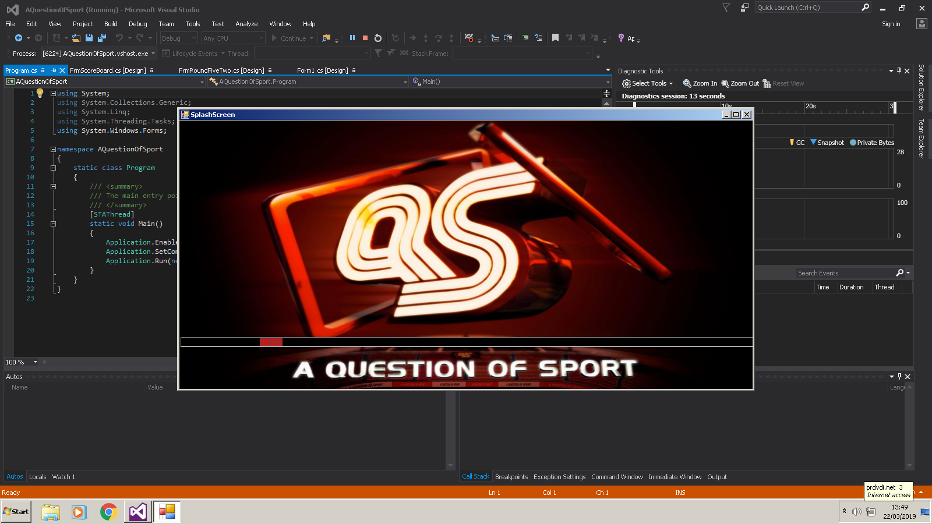Final Interface 1 design:

This is the final screen design of the loading/Splash screen. This is the first screen the user meets when the program is loaded. This screen features a progress bar, which continuously passes until it has loaded, where it will move onto the next form.

|  |  |  |
| --- | --- | --- |
| GUI Object | Property | Setting |
| Background | Image | “Question of sport 1.jpg” |
| pgBar | Colour  Min Value  Max Value  Style | Red  0  500  Marquee |

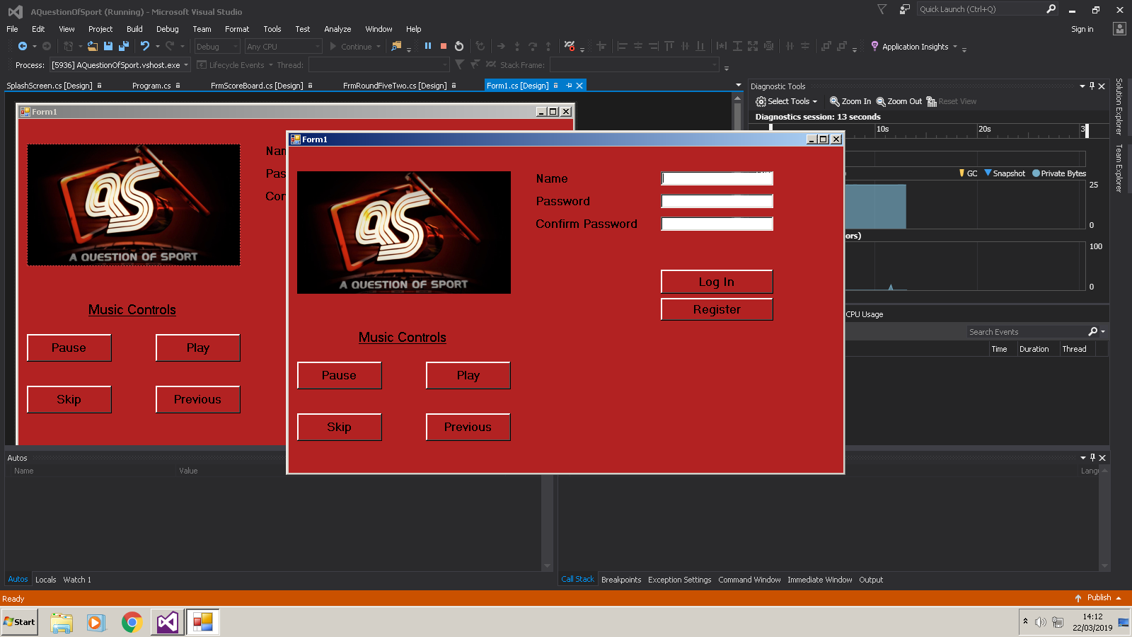Final Interface 2 Design:

This is the final screen design of the Log in screen. This is the screen the user is met with once the splash screen has loaded. This screen features a text box, where the user will enter their details in order to log in or register. It also features a music control section, which will control what and if music is playing. Once the user has created an account, or entered their existing details, they press log in, which will make a message box appear, telling them they have successfully logged in, and the screen will move to the next form.

|  |  |  |
| --- | --- | --- |
| GUI Object | Property | Setting |
| label1 | Text  Size  Style  ForeColour  BackColour | “Name:”  12  Microsoft Sans Serif, Bold  Controltext  FireBrick |
| label2 | Text  Size  Style  ForeColour  BackColour | “Password:”  12  Microsoft Sans Serif, Bold  ControlText  FireBrick |
| lblCPassWord | Text  Size  Style  ForeColour  BackColour | “Confirm Password:”  12  Microsoft Sans Serif, Bold  ControlText  FireBrick |
| pictureBox1 | Image  Size Mode | “Question of sport 1.jpg”  StretchImage |
| Background | Colour | FireBrick |
| button1 | Text  Size  Style  ForeColour | “Log In”  12  Microsoft Sans Serif, Bold  ControlText |
| btnRegister | Text  Size  Style  ForeColour | “Register”  12  Microsoft Sans Serif, Bold  Controltext |
| label3 | Text  Size  Style  ForeColour  BackColour | “Music Controls”  14  Microsoft Sans Serif, Bold, Underlined  ActiveCaptionText  FireBrick |
| button2 | Text  Size  Style  ForeColour | “Pause”  12  Microsoft Sans Serif, Bold  ControlText |
| button3 | Text  Size  Style  ForeColour | “Play”  12  Microsoft Sans Serif, Bold  ControlText |
| button5 | Text  Size  Style  ForeColour | “Skip”  12  Microsoft Sans Serif, Bold  ControlText |
| button4 | Text  Size  Style  ForeColour | “Previous”  12  Microsoft Sans Serif, Bold  ControlText |

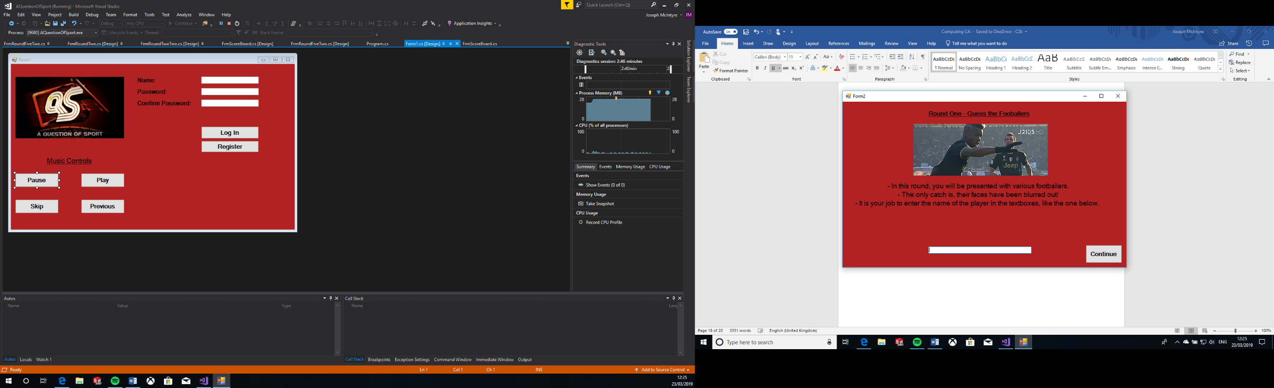Final Interface 3 Design:

This is the final screen design of the introduction page to the first section. This is the screen the user is met with once they have successfully logged in. This screen features a gif, which shows a short video related to the upcoming section. This form also features instructions on how to answer the upcoming questions for this section. Once the user has read and fully understands the instructions, they can press the continue button in the bottom right corner to bring them to the next form.

|  |  |  |
| --- | --- | --- |
| GUI Object | Property | Setting |
| Background | Colour | Firebrick |
| PictureBox1 | Gif | “Pogba dab.gif” |
| Label1 | Text  Size  Style  ForeColour | “Round One – Guess the Footballers”  12  Microsoft Sans Serif, Bold, Underlined  ControlText |
| BtnContinue | Text  Size  Style  ForeColour | “Continue”  12  Microsoft Sans Serif, Bold  InfoText |
| Label2 | Text  Size  Style  ForeColour | “- In this round, you will be presented with various footballers.  - The only catch is, their faces have been blurred out!  - It is your job to enter the name of the player in the textboxes, like the one below.”  14  Microsoft Sans Serif, Bold  ControlText |

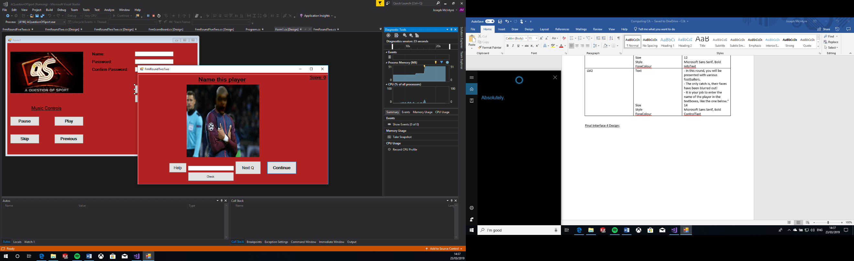Final Interface 4 Design:

This is the final screen design of first section of questions. This screen features an image, which shows a variety of footballers, whose face has been blurred out. The user inputs into the text box the name of who they think the footballer is, and presses check. If the user answers correctly, a message box will appear, notifying them, and their score will increase by one on the counter. If the user is stuck on a question, they can press the help button, which will give them a hint to the answer. Alternatively, they can skip the current question by clicking the Next Q button. Once the user has answered all questions, the next form will load.

|  |  |  |
| --- | --- | --- |
| GUI Object | Property | Setting |
| Background | Colour | Firebrick |
| label11 | Text  Size  Style  ForeColour | “Score: ”  12  Microsoft Sans Serif, Bold, Underlined  ControlText |
| button1 | Text  Size  Style  ForeColour | “Continue”  12  Microsoft Sans Serif, Bold  ControlText |
| button2 | Text  Size  Style  ForeColour | “Next Q”  12  Microsoft Sans Serif  ControlText |
| button3 | Text  Size  Style  ForeColour | “Check”  8  Microsoft Sans Serif  ControlText |
| button13 | Text  Size  Style  ForeColour | “Help”  12  Microsoft Sans Serif  ControlText |
| grpBox1-10 | BackColour | FireBrick |
| pictureBox1-10 | Image  Size Mode | “antoine-griezmann 2.jpg”  “De-Bruyne 2.jpg”  “Gerard-Pique 2.jpg”  “Leigh Griffiths 2.jpg”  “mBappe 2.jpg”  “Paulo-Dybala-Juventus 2.jpg”  “Ramos 2.jpg”  “Reus 2.jpg”  “robert-lewandowski 2.jpg”  “Salah 2.jpg”  StretchImage |
| label1-10 | Text  Size  Style | “Name this player”  18  Microsoft Sans Serif, Bold, Underlined |

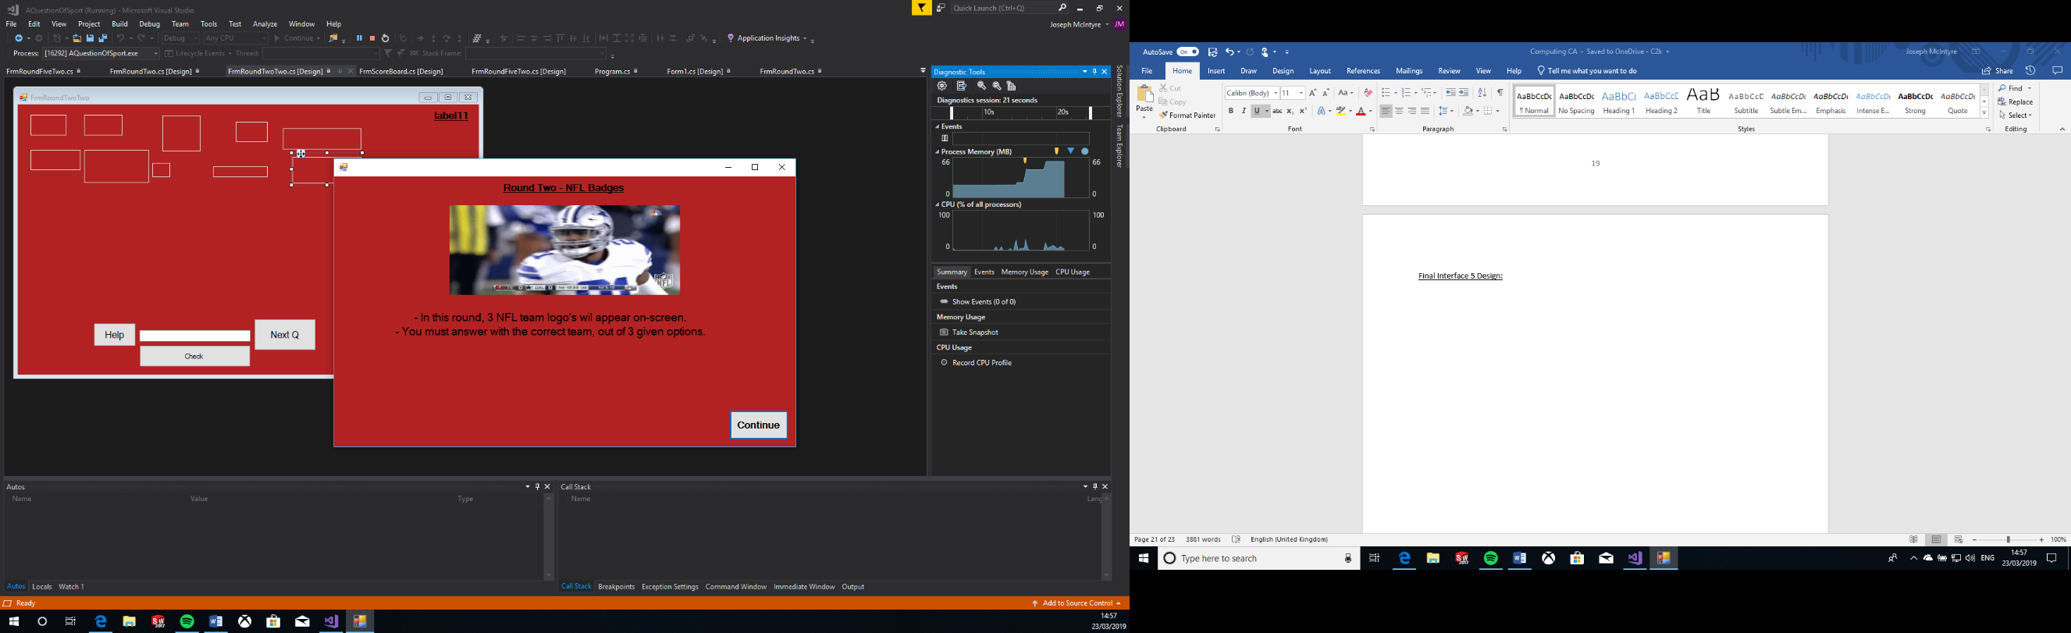Final Interface 5 Design:

|  |  |  |
| --- | --- | --- |
| GUI Object | Property | Setting |
| Background | Colour | Firebrick |
| pictureBox1 | Gif | “Zeke.gif” |
| label1 | Text  Size  Style  ForeColour | “Round Two – NFL Badges”  12  Microsoft Sans Serif, Bold, Underlined  ControlText |
| button1 | Text  Size  Style  ForeColour | “Continue”  12  Microsoft Sans Serif, Bold  InfoText |
| label2 | Text  Size  Style  ForeColour | “- In this round, 3 NFL team logo's will appear on-screen.  - You must answer with the correct team, out of 3 given options.”  14  Microsoft Sans Serif, Bold  ControlText |

This is the final screen design of the introduction page to the second section. This screen features a gif, which shows a short video related to the upcoming section. This form also features instructions on how to answer the upcoming questions for this section. Once the user has read and fully understands the instructions, they can press the continue button in the bottom right corner to bring them to the next form.

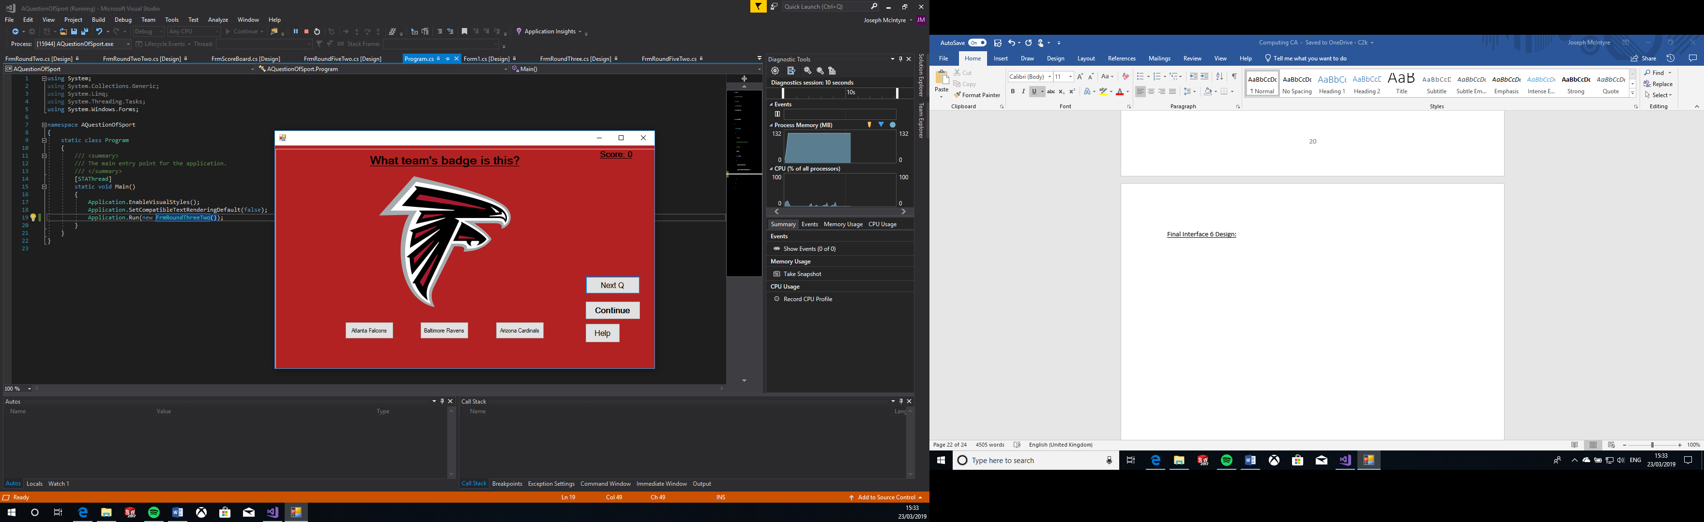Final Interface 6 Design:

This is the final screen design of second section of questions. This screen features an image of a variety of NFL team logos. The user selects from the 3 options below which one they think is the correct team. If the user answers correctly, a message box will appear, notifying them, and their score will increase by one on the counter. If the user is stuck on a question, they can press the help button, which will give them a hint to the answer. Alternatively, they can skip the current question by clicking the Next Q button. Once the user has answered all questions, the next form will load.

|  |  |  |
| --- | --- | --- |
| GUI Object | Property | Setting |
| Background | Colour | Firebrick |
| label11 | Text  Size  Style  ForeColour | “Score: ”  12  Microsoft Sans Serif, Bold, Underlined  ControlText |
| button1 | Text  Size  Style  ForeColour | “Continue”  12  Microsoft Sans Serif, Bold  ControlText |
| button32 | Text  Size  Style  ForeColour | “Next Q”  12  Microsoft Sans Serif  ControlText |
| button33 | Text  Size  Style  ForeColour | “Help”  12  Microsoft Sans Serif  ControlText |
| grpBoxTwo1-10 | BackColour | FireBrick |
| pictureBox1-10 | Image  Size Mode | “49’ers.png”  “Bears.png”  “Broncos.png”  “Chargers.png”  “Dallas_Cowboys.svg.png”  “Dolphins.png”  “Falcons.png”  “Packers.png”  “Patriots.png”  “Seahawks.png”  StretchImage |
| label1-10 | Text  Size  Style | “What team’s badge is this?”  18  Microsoft Sans Serif, Bold, Underlined |
| button2-31 | Text  Size  Style | “Seattle Seahawks”  “Philadelphia Eagles”  “Carolina Panthers”  “Buffalo Bills”  “Detroit Lions”  “Denver Broncos”  “San Francisco 49ers”  “Seattle Seahawks”  “New Orleans Saints”  “Atlanta Falcons”  “Baltimore Ravens”  “Arizona Cardinals”  “Cincinnati Bengals”  “Cleveland Browns”  “Chicago Bears”  “LA Chargers”  “Indianapolis Colts”  “Tampa Bay Buccaneers”  “Houston Texans”  “Dallas Cowboys”  “Oakland Raiders”  “Tennessee Titans”  “New England Patriots”  “New York Giants”  “Carolina Panthers”  “Minnesota Vikings”  “Miami Dolphins”  “Kansas City Chiefs”  “Green Bay Packers”  “Pittsburgh Steelers”  8  Microsoft Sans Serif |

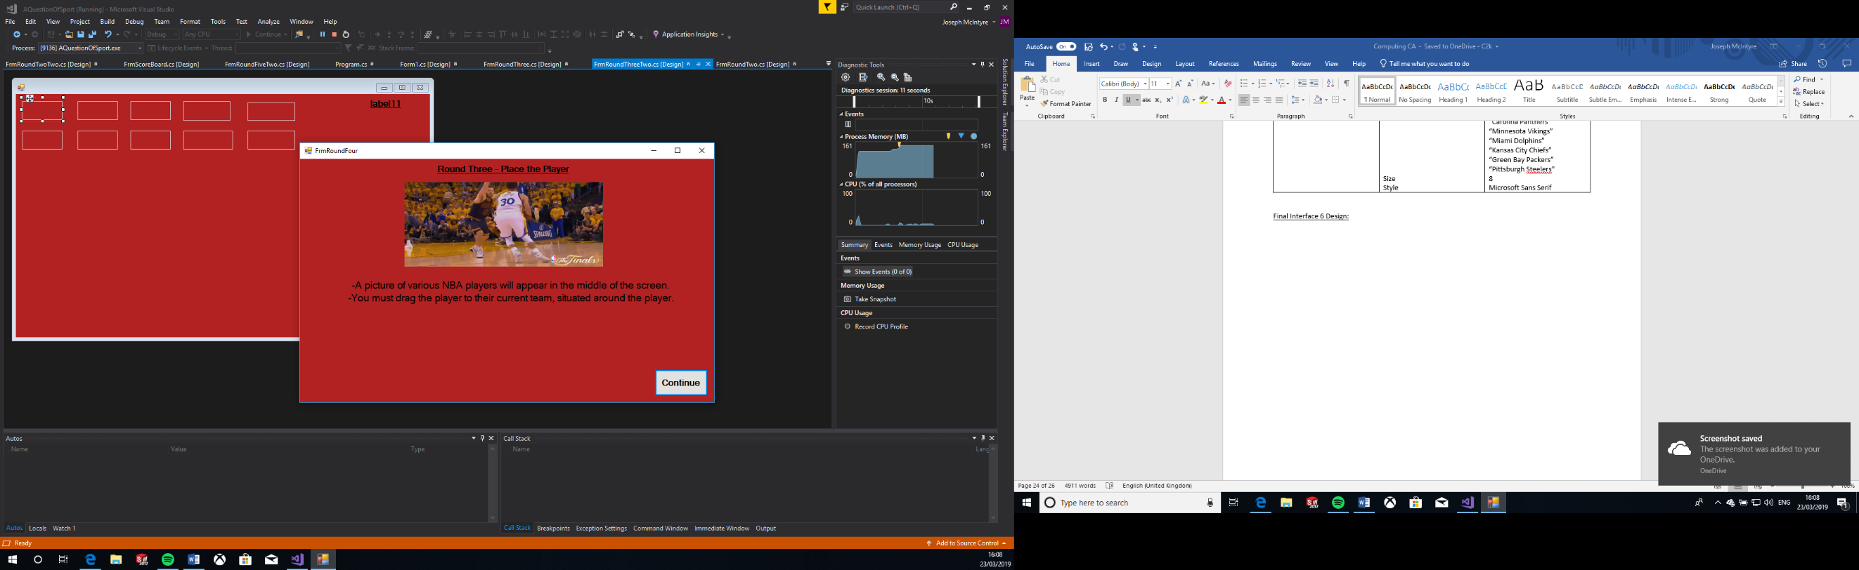Final Interface 7 Design:

This is the final screen design of the introduction page to the third section. This screen features a gif, which shows a short video related to the upcoming section. This form also features instructions on how to answer the upcoming questions for this section. Once the user has read and fully understands the instructions, they can press the continue button in the bottom right corner to bring them to the next form.

|  |  |  |
| --- | --- | --- |
| GUI Object | Property | Setting |
| Background | Colour | Firebrick |
| pictureBox1 | Gif | “Steph.gif” |
| label1 | Text  Size  Style  ForeColour | “Round Three - Place the Player”  12  Microsoft Sans Serif, Bold, Underlined  ControlText |
| button1 | Text  Size  Style  ForeColour | “Continue”  12  Microsoft Sans Serif, Bold  InfoText |
| label2 | Text  Size  Style  ForeColour | “-A picture of various NBA players will appear in the middle of the screen.  -You must drag the player to their current team, situated around the player.”  14  Microsoft Sans Serif, Bold  ControlText |

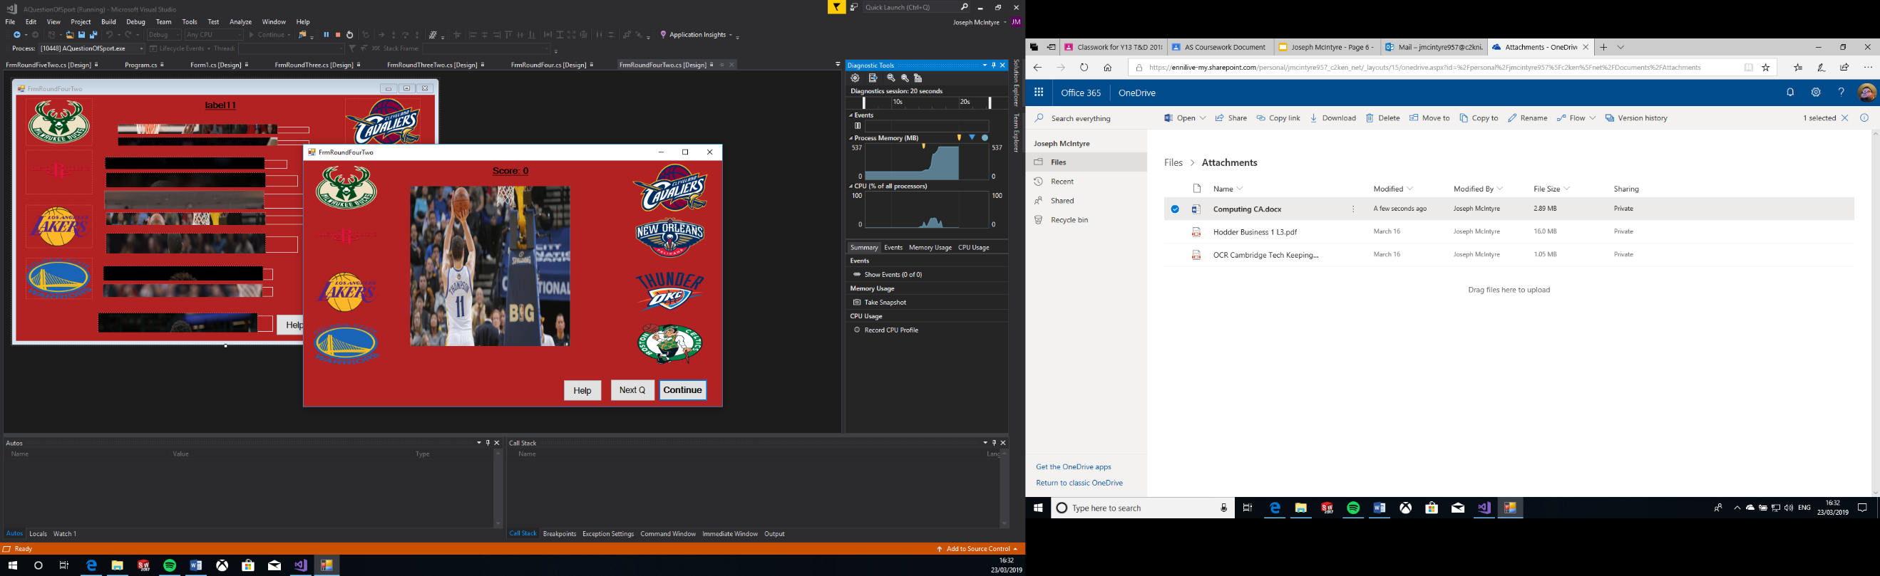Final Interface 8 Design:

This is the final screen design of third section of questions. This screen features an image of an NBA player, surrounded by different NBA teams’ logos. The user must drag the player to the correct team, who they currently play for. If the user answers correctly, a message box will appear, notifying them, and their score will increase by one on the counter. If the user is stuck on a question, they can press the help button, which will give them a hint to the answer. Alternatively, they can skip the current question by clicking the Next Q button. Once the user has answered all questions, the next form will load.

|  |  |  |
| --- | --- | --- |
| GUI Object | Property | Setting |
| Background | Colour | Firebrick |
| label11 | Text  Size  Style  ForeColour | “Score: ”  12  Microsoft Sans Serif, Bold, Underlined  ControlText |
| button1 | Text  Size  Style  ForeColour | “Continue”  12  Microsoft Sans Serif, Bold  ControlText |
| button2 | Text  Size  Style  ForeColour | “Next Q”  12  Microsoft Sans Serif  ControlText |
| button3 | Text  Size  Style  ForeColour | “Help”  12  Microsoft Sans Serif  ControlText |
| groupBox1-10 | BackColour | FireBrick |
| pictureBox1-10 | Image  Size Mode | “Anthony Davis.jpg”  “Curry.jpg”  “Greek freak.jpg”  “Irving.jpg”  “James Harden.jpg”  “JR Smith.jpg”  “Klay Thompson.png”  “Lebron.jpg”  “Lonzo Ball.jpg”  “Russell Westbrook.jpg”  StretchImage |
| pictureBox11-18 | Image  Size Mode | “Bucks.png”  “Cavs.png”  “Celtics.png”  “Lakers.png”  “Pelicans.png”  “Rockets.png”  “Thunder.png”  “warriors.png”  StretchImage |

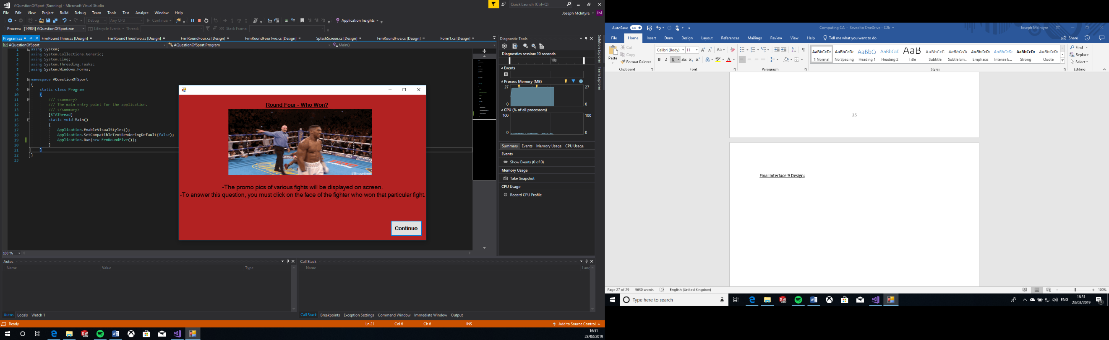Final Interface 9 Design:

This is the final screen design of the introduction page to the fourth section. This screen features a gif, which shows a short video related to the upcoming section. This form also features instructions on how to answer the upcoming questions for this section. Once the user has read and fully understands the instructions, they can press the continue button in the bottom right corner to bring them to the next form.

|  |  |  |
| --- | --- | --- |
| GUI Object | Property | Setting |
| Background | Colour | Firebrick |
| pictureBox1 | Gif | “Anthony Joshua.gif” |
| Label1 | Text  Size  Style  ForeColour | “Round Four - Who Won?”  12  Microsoft Sans Serif, Bold, Underlined  ControlText |
| button1 | Text  Size  Style  ForeColour | “Continue”  12  Microsoft Sans Serif, Bold  InfoText |
| label2 | Text  Size  Style  ForeColour | “-The promo pics of various fights will be displayed on screen.  -To answer this question, you must click on the face of the fighter who won that particular fight.”  14  Microsoft Sans Serif, Bold  ControlText |

Final Interface 10 Design: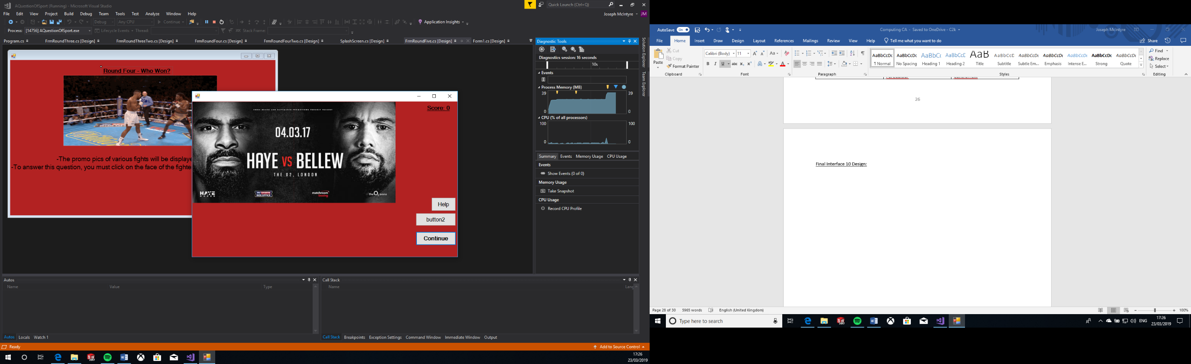

This is the final screen design of the fourth and final section of questions. This screen features a promo pic of a fight, surrounded by different NBA teams’ logos. The user must click on the face of the winner of that fight. If the user answers correctly, a message box will appear, notifying them, and their score will increase by one on the counter. If the user is stuck on a question, they can press the help button, which will give them a hint to the answer. Alternatively, they can skip the current question by clicking the Next Q button. Once the user has answered all questions, a message box will appear, that will notify if they have achieved a new high score or not. The next form will then load, which will show the user their best score.

|  |  |  |
| --- | --- | --- |
| GUI Object | Property | Setting |
| Background | Colour | Firebrick |
| pictureBox1 | Gif | “Anthony Joshua.gif” |
| groupBox1-16 | BackColour | BrickRed |
| label1 | Text  Size  Style  ForeColour | “Round Four - Who Won?”  12  Microsoft Sans Serif, Bold, Underlined  ControlText |
| button1 | Text  Size  Style  ForeColour | “Continue”  12  Microsoft Sans Serif, Bold  InfoText |
| label11 | Text  Size  Style  ForeColour | “Score: ”  12  Microsoft Sans Serif, Bold, Underlined  ControlText |

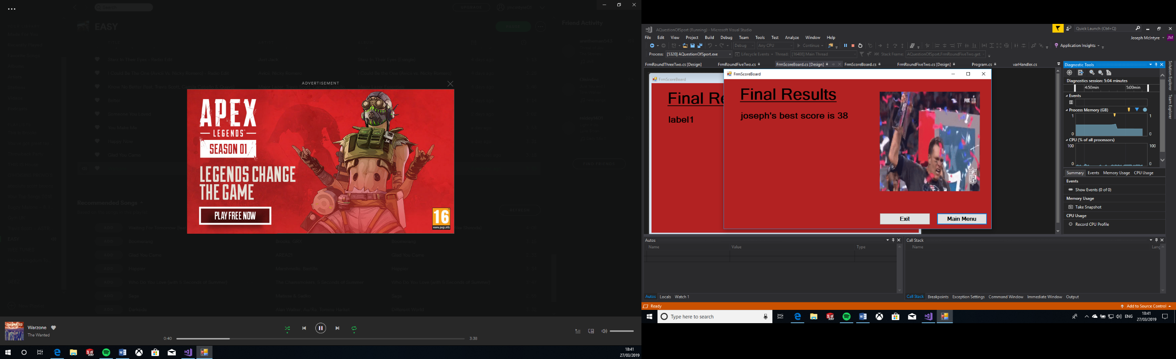Final Interface 11 Design:

This is the final screen design of the final page, which is the scores page. This page will display the current users best score, and depending on how they performed, a certain Gif will appear. The user can then decide whether to go back to the menu, by pressing the main menu button, or exit the quiz, where they’ll be met with a message box confirming their decision.

|  |  |  |
| --- | --- | --- |
| GUI Object | Property | Setting |
| Background | Colour | Firebrick |
| pictureBox1  pictureBox2  pictureBox3  pictureBox4 | Gif  Gif  Gif  Gif | “decent.gif”  “dj khaledd.gif”  “Lebron.gif”  “Brady.gif” |
| groupBox1st-4th | BackColour | FireBrick |
| label2 | Text  Size  Style  ForeColour | “Final Results”  36  Microsoft Sans Serif, Bold, Underlined  ControlText |
| label1 | Text  Size  Style  ForeColour | “ 's best score is ”  20  Microsoft Sans Serif, Bold  ControlText |
| button2 | Text  Size  Style  ForeColour | “Exit”  12  Microsoft Sans Serif, Bold  ControlText |
| button1 | Text  Size  Style  ForeColour | “Main Menu”  12  Microsoft Sans Serif, Bold  ControlText |

Chapter 3 – Testing Strategy

3.0 - Test Plan

I will be using the following methods of testing to evaluate and ensure that my quiz meets all the requirements I have set previously.

**Alpha testing-** Alpha testing is testing of an application when development is about to complete. Minor design changes can still be made as a result of alpha testing. It is typically performed by a group that is independent of the design team, but still within the company, e.g. in-house software test engineers, or software QA engineers.

**Beta testing-** Beta testing is the second level, external pilot-test of a software before commercial quantity production. At the beta test stage, the product has already passed through the alpha test and glaring defects have been removed. But it is released to selected customers for testing under normal, everyday conditions of use to spot the remaining flaws.

|  |  |  |  |
| --- | --- | --- | --- |
| Test no. | Test Data | Reason for test | Expected Outcome |
| 1.SplashScreen | pgBar with a value of 500. | To ensure that when the progress bar fills up to its maximum value of 500, it loads the next screen. | The progress bar fills up to the value of 500, and then loads the main menu, which is the next page. |
| 2.Form1 | Click of button2. | To check if this button successfully pauses the music. | The music playing at that time will pause. |
| 3.Form1 | Click of button3. | To check if this button successfully plays the music once paused. | The music that has been paused will continue to play again. |
| 4.Form1 | Click of button5. | To check if this button successfully skips the current song and plays the next. | The current song will stop playing, and the next will play. |
| 5.Form1 | Click of button4. | To check if this button will successfully play the previous song. | The current song will stop, and the previous song will play. |
| 6.Form1 | Entering correct Login details:  Name: “Joseph”  Password: “Password1” | To ensure that when correct login details are entered and the log in button is pressed, the program accepts them, and loads the next screen. | A message box will appear, notifying the user of a successful log in, and the next screen will load. |
| 7.Form1 | Click of btnRegister. | To ensure that if the user clicks this button, it makes the confirm password option available. | The user clicks the button, and the confirm password option appears. |
| 8.Form1 | Entering details in txtConfirmPass. | To ensure that when the user types their new password into the confirm password textbox, it creates a new user. | The user re-enters their new password, and clicks register. A message box appears, notifying them a new user has been added. |
| 9.Form1 | Entering incorrect password details.  Name: “Joseph”  Password: “Joseph12” | To ensure that if the user enters an incorrect password, it does not allow them to log in, or move onto the next screen. | A message box appears, notifying the user that their login details are incorrect. |
| 10.Form1 | Entering incorrect username details.  Name: “Joe”  Password: “Password1” | To ensure that if the user enters an incorrect name, it does not allow them to log in, or move to the next screen. | A message box appears, notifying the user that their login details are incorrect. |
| 11.FrmRoundTwo | Click of BtnContinue. | To ensure that when the user presses the continue button, it loads the next screen. | The next screen is loaded. |
| 12.FrmRoundTwoTwo | Click of button2. | To ensure that when this button is clicked, it loads the next question on this page. | The next question appears, which is a picture of a different player than previously. |
| 13.FrmRoundTwoTwo | Click of button13. | To ensure that when this button is pressed, it gives the user help for the current question. | A message box appears, which gives the user a hint as to what the answer is; the footballers name. |
| 14.FrmRoundTwoTwo | Entering the correct name of a player.  “Salah” | To ensure that when the correct answer is entered, and the check button is pressed, the program knows it is a correct answer. | A message box appears notifying the user their answer was correct, the score counter goes up by one, and the next question is loaded. |
| 15.FrmRoundTwoTwo | Label11 | To ensure that when the user answers a question correctly, the score displayed increases by one. | The user answers the question correctly, and the score counter counts up by one. |
| 16.FrmRoundTwoTwo | Entering an incorrect name in the text box. | To ensure that when the user enters an incorrect answer, the program notifies the user, and moves onto the next question. | A message box appears notifying the user that their answer was incorrect, and the next question is loaded. |
| 17.FrmRoundTwoTwo | Click of button1. | To ensure that when this button is clicked, it loads the next screen of the program. | The user clicks the button, and the next screen is loaded. |
| 18.FrmRoundTwoTwo | Answering all questions. | To ensure that once the user has answered all questions, the next page of the program is loaded. | The user answers all questions, and the next section of the quiz is loaded in automatically. |
| 19.FrmRoundThree | Click of button1 | To ensure that when this button is clicked, it loads the next screen of the program. | The user clicks the button, and the next screen is loaded. |
| 20.FrmRoundThreeTwo | grpBoxTwo1 | To ensure that when the question has been answered, the next groupbox is loaded, which contains the next question. | The user selects an answer, and a message box notifies the user whether it was correct or not, and the next groupbox is loaded. |
| 21.FrmRoundThreeTwo | Click of the correct answer.  Answer:  button5 | To ensure that when the user clicks the correct answer for the question, they are notified by the program. | A message box appears, notifying the user they’ve selected the correct answer, the score counter will increase by one, and the next question will load. |
| 22.FrmRoundThreeTwo | Click of an incorrect answer. | To ensure that when the user selects an incorrect answer, they are notified by the program. | A message box will appear, notifying the user that their answer was incorrect, and the next question will load. |
| 23.FrmRoundThreeTwo | Click of button32 | To ensure that when this button is clicked, the next question appears. | The next question will load onto the screen. |
| 24.FrmRoundThreeTwo | Click of button33 | To ensure that when this button is clicked, the user is provided with help for the current question. | A message box will appear, which will give the user a clue as to what the correct answer is for that question |
| 25.FrmRoundFour | Click of button1 | To ensure that when this is clicked, it brings the user to the next page of the program. | The next screen of the program will be loaded on screen. |
| 26.FrmRoundFourTwo | Dragging the correct player image to the team image.  Player: pictureBox9  Team: pictureBox14 | To ensure that when the user drags the correct player image to the team image, the program notifies the user. | A message box will appear, notifying the user their answer was correct, the score counter will increase by one, the next question will load, and the team image will reset to its original form. |
| 27.FrmRoundFourTwo | Dragging the incorrect player image to the team image. | To ensure that when the user drags the incorrect player image to a team image, the program notifies the user. | A message box will appear, notifying the user their answer was wrong, the team image will reset back to its original state, and the next question will load |
| 28.FrmRoundFourTwo | Answering all questions. | To ensure that once the user has dragged all images in the centre, answering every question, the next page of the program is loaded. | The user answers all questions, and the next section of the quiz is loaded in automatically. |
| 29.FrmRoundFiveTwo | Clicking the correct fighter.  Image: pictureBox15 | To ensure that when the correct image is clicked, the program notifies the user, and counts up the score. | A message box will appear, notifying the user their answer was correct, the score counter will increase by one and the next question will load. |
| 30.FrmScoreBoard | groupBox1st becoming visible. | To ensure that if the user scores above 30, the groupBox2nd becomes visible. | The groupBox1st appears on the page, containing a Gif. |
| 31.FrmScoreBoard | Click of button1. | To ensure that if the user wants to return to the main menu after the quiz is finished, this button allows them to do so. | Once the button has been clicked, the program will load the main menu screen. |
| 32.FrmScoreBoard | Click of button2. | To ensure that if the user clicks button2 to exit the quiz, it allows them to do so. | A message box appears, asking the user if they are sure, and if they press yes, the program will close, if they press no, the message box will close, and they will be returned to the scores screen. |
| 33.FrmScoreBoard | label1 | To ensure that it displays the current users best score. | The users best score ever achieved will be shown on a label. |

3.1 - Test Results

|  |  |  |
| --- | --- | --- |
| Test No. | Actual Outcome | Evidence |
| 1.SplashScreen | Progress bar fills to 500, and the main menu automatically loads. |  |
| 2.Form1 | The current music being played is paused. | The message box seen here in the evidence is only used to illustrate the fact that music has been paused and would not be a feature otherwise. |
| 3.Form1 | The music being played before resumes from the same point. | The message box seen here in the evidence is only used to illustrate the fact that music has been paused and would not be a feature otherwise. |
| 4.Form1 | The next track is played. | The message box seen here in the evidence is only used to illustrate the fact that music has been paused and would not be a feature otherwise. |
| 5.Form1 | The previous song is played. | The message box seen here in the evidence is only used to illustrate the fact that music has been paused and would not be a feature otherwise. |
| 6.Form1 | The program welcomes the user and loads the next screen. |  |
| 7.Form1 | The confirm password label and text box appears, allowing the use to create their password. |  |
| 8.Form1 | The user confirms their password, and presses register, and a new user profile is created. |  |
| 9.Form1 | A message box appears, telling the user their details are wrong. |  |
| 10.Form1 | A message box appears, telling the user their details are wrong. |  |
| 11.FrmRoundTwo | The next screen is loaded. |  |
| 12.FrmRoundTwoTwo | The next groupbox containing the next question on the page is loaded. |  |
| 13.FrmRoundTwoTwo | A message box appears, giving the user a hint based on the specific question they are stuck on. |  |
| 14.FrmRoundTwoTwo | A message box appears telling the user their answer was correct, the next groupbox is loaded, and the users score is increased by one. |  |
| 15.FrmRoundTwoTwo | The score counter increments by one. |  |
| 16.FrmRoundTwoTwo | A message box notifies the user their answer was incorrect, and the next groupbox with the next question is loaded. |  |
| 17.FrmRoundTwoTwo | The next screen of the quiz is loaded, which is the next section. |  |
| 18.FrmRoundThreeTwo | The user answers all questions, right or wrong, and the next screen of the quiz is automatically loaded. |  |
| 19.FrmRoundThreeTwo | The next screen of the quiz is loaded. |  |
| 20.FrmRoundThreeTwo | The user clicks an answer to the question, a message box notifies them if it was correct or incorrect, and the next groupbox containing the next question is loaded. |  |
| 21.FrmRoundThreeTwo | A message box appears, telling the user their answer was correct, their score increases by one and the next question is loaded. |  |
| 22.FrmRoundThreeTwo | A message box appears, telling the user their selected answer is wrong. |  |
| 23.FrmRoundThreeTwo | The next picture box is loaded, which contains the next question of the section. |  |
| 24.FrmRoundThreeTwo | A message box appears, giving the user a hint or clue to the answer of the current question. |  |
| 25.FrmRoundFour | The next screen of the form is loaded. |  |
| 26.FrmRoundFourTwo | A message box appears, telling the user their answer was correct, the score counter increases by one, the next question loads, and the team image reset to its original form. |  |
| 27.FrmRoundFourTwo | A message box appears, telling the user their answer was wrong, the team image resets to its original form and the next question is loaded. |  |
| 28.FrmRoundFourTwo | After the user has answered all questions, the next screen will load. |  |
| 29.FrmRoundFiveTwo | The score counter increments by one. |  |
| 30.FrmScoreBoard | The groupbox1st appears, which contains a Gif. |  |
| 31.FrmScoreBoard | The user is returned to the main menu. |  |
| 32.FrmScoreBoard | A message box appears, asking the user to confirm their choice, and if yes is pressed, the program will close. |  |
| 33.FrmScoreBoard | The users best score is displayed on the screen. |  |

Chapter 4 – Evaluation

4.0 – Evaluation of design objectives

|  |  |  |  |
| --- | --- | --- | --- |
|  | **User requirements** | **Design objectives** | **Objective evaluation** |
| 1 | The quiz should have a loading screen. | I will create a loading screen which will appear when the program has begun. | At the beginning of the quiz, a loading screen appears. A continuous progress bar then loads until the quiz has loaded. |
| 2 | The quiz should be for the 4th and 5th year groups. | It should be able to be easily answered by 4th and 5th years. | The quiz has been designed so that it can be answered by 4th and 5th years but still provides them with a challenge. |
| 3 | System quiz use text boxes, multiple choice, and click and drag answering techniques. | I will create questions that use each of these answering techniques. | Each section of the quiz incorporates a different method of answering the question. |
| 4 | The quiz should include 30-40 questions. | I will create 30-40 questions. | The quiz features 38 questions in total, asked over 4 different sections. |
| 5 | The users current score should be displayed on screen. | I will create a score counter, which will display their current score. | On every question page, the users current score is shown above the questions, at the top of the page. After every question is correctly answered, the score counter will increase by one to reflect this. |
| 6 | The quiz’s theme should use one constant colour. | I will use the same colour for each page. | Every section of the quiz uses the same colour, FireBrick. |
| 7 | The quiz should include a main menu. | I will create a main menu which will allow the user to log on with their own account. | The user is met with a main menu once the splash screen is loaded, and it allows them to log in or create a new account. |
| 8 | The quiz should include a button to skip the current question. | I will include a button which allows the user to move onto the next question, if they are stuck. | In every section of questions, there is a button to skip the current question, if the user is stuck. |
| 9 | Each user should have their own log-in information. | I will allow users to create an account if they do not have one already. | On the main menu the user can create a new account which will be saved, if they do not already have one. |
| 10 | The quiz should include a leader board. | The quiz will include a leader board page, which displays the users best score at the end of the quiz. | At the end of the quiz, when all questions have been answered, the user is met with a page that will show them their best ever score, across multiple attempts. |
| 11 | The quiz should not be case sensitive. | Questions can be answered in lower or upper case letters. | In questions that required a typed input, the user is able to enter in either capitals or lower case, or a mixture of both, and the quiz accepts it. |
| 12 | The quiz should include an introduction page before each section. | An introduction page will be included, which will show the user how to answer the questions for that section. | Before every question section, there is an introductory page, which gives the user instructions on how to enter the questions to follow. |
| 13 | The quiz should include both gif’s and pictures. | Pictures will be used for the actual questions, while Gifs will be used on the introduction pages for each section. | Gifs are used in the centre of every introductory page before each section, while questions are used in each question that follows. |
| 14 | The pictures and gifs should be in various positions. | The Gifs will be placed in the centre of the page, while pictures will be positioned in various places. | Gifs are placed in the centre of every introductory page, while pictures are placed in various positions throughout the questions. |
| 15 | The user should interact with the quiz using a keyboard and mouse. | Questions will rotate between answers that should be entered through typing, and answers that are entered using a mouse. | The questions incorporate both the keyboard and mouse, through a variety of answering methods, such as click and drag and typing the answer. |
| 16 | The quiz should include music, with a choice of songs and to mute. | A music player construct will be included on the menu page, which allows the user to select a song, or mute the music completely. | A media player is included on the main menu, which allows the user to skip to the next song, pause it, play it or play the previous song. |
| 17 | The users score should be recorded at the end. | A leader board at the end of the quiz will display the users score. | The users score is given on a score page at the end of the quiz, as well as a Gif, which reflects the user’s performance. |
| 18 | The score should be shown as a score out of the total marks available. | The users score will be displayed as a score out of 38 on the leader board. | The users score is given on a label, showing their score out of 38, which is the highest score possible. |
| 19 | The user should be informed if they’ve answered a question wrong. | A message box will appear, telling the user that they have answered the question incorrectly. | On every question page, if a user answers a question incorrectly, a message box appears, telling them they have answered incorrectly. |
| 20 | The pupil should be informed they’ve logged on successfully. | I will create a system that notifies the user when they log on with correct details. | A message box appears, telling the user that they have successfully logged on with the details they have entered. |
| 21 | The quiz should include a help button for each question. | A button will be included on each question, which will give the user help. | On each page of questions, there is a help button, which when pressed displays a message box, which gives the user a hint as to what the answer is. |
| 22 | The questions should be asked in random order. | In each section, the questions will appear in a random order each time. | The sections of questions are always asked in the same order, however the order as to what the actual questions are asked in is completely random. |

4.1 - Positive aspects of the system

The biggest positive with my program is that it runs smoothly and is easy to complete for beginners. The use of user-friendly aspects, such as music and Gifs, makes it more pleasing for the user and provides them with an enjoyable experience. Using the same colour and similar layout for most forms also makes the program more user-friendly and easier to use. Allowing the user to skip through multiple songs also gives the user a sense of freedom when using the program, as they can listen to a song that is to their taste.

Using introduction pages to questions, which gives the user instructions for the questions also makes the quiz more user-friendly. The quiz is also challenging for the 4th and 5th year pupils, who it is intended for. It is not impossible; however, it provides a challenge for them.

The quiz is also up to date, and features current topics, which the user should recognise. Current players, and recent fights are just two examples of the up to date topics which the user is quizzed on. Furthermore, the random order of the questions improves the playback ability for the user, as they should not be able to answer the quiz from memory.

Through testing and repeated use, my quiz has shown no signs of any bugs or glitches and has run smoothly throughout its whole creation. As a result, I am confident that when used by its intended audience of 4th and 5th year pupils, they will not experience any problems with the program.

The system also includes a range of techniques which are required to answer the questions, from click and drag, to a typed answer. This helps keep the user’s attention and keeps them engaged with the quiz. It also allows the user to gain an understanding on the various use of methods that can be used to answer questions in a computer program.

I am also confident that my quiz has met all user requirements set out by Mr. McCloskey through the questionnaire at the beginning of this project. Everything that was set out in the design objectives at the start of this project has been met, and so I feel as if this quiz has successfully achieved what it was intended to do. It provides Mr. McCloskey with the alternative to class tests that he had requested beforehand.

4.2 - Future enhancements

The main disadvantage of the quiz is that the questions are always the same but asked in a different order each time. This could make the quiz repetitive, and the user could eventually become bored or lose interest in the quiz. This could make the quiz a tedious task for the user, and they could also begin to memorise the questions and their answers, giving them an unfair advantage. If I was to make any amendments to the quiz, I would add more questions, and then decrease the number of questions asked, so that the same question is not asked every time.

Furthermore, there are only 4 sections of questions in the quiz, and there as a result, there is only 4 different sports included in the quiz. Therefore, an improvement to this quiz I would make would be to include a few more sections, which questions the user on other sports, such as golf or rugby.

Also, at this moment, there is only a choice of 3 songs to play during the quiz. A modification to the quiz I would make therefore, would be to add more songs, and make a list on the main menu so that the user can quickly select which one they would like to listen to.

4.3 – Evaluation of my performance

Throughout the process of creating my quiz program, I have gained and developed various skills. My preparation and creative skills were needed at the beginning of this task, as I had to plan and design every element and question of my quiz.

As time went on, my organisational skills improved, as I learned where to save each part of the quiz I needed in different folders on my USB, and eventually, I moved my coursework document to OneDrive, so that the risk of losing it with my USB or forgetting it was eliminated.

Throughout the process of designing the questions, I also learned quite a lot on the sports I used. This was especially true when it came to creating the basketball section, where I actually learned quite a lot about the teams and players included.

My understanding of coding and program development also progressed significantly during this process, as I have discovered simpler and more efficient methods of coding my program to do different things. An example of this is using group boxes to display different questions on the same form, instead of having to take a new form for each question.

Lastly, my time management has also developed, as I set myself deadlines to have certain parts or aspects of the program completed. For example, I gave myself a week to get every help button on the question pages working correctly. Overall, this helped me complete my program efficiently, thoroughly and on time.

However, during the creation of my quiz, I did run into a persistent problem. With the addition of the media library to play music from the file, and the incorporation of over 50 images and Gifs, the program developed a bug where it would use an absurd amount of memory. At most times the computers in school would be running with their memory running at 98% capacity. This made it extremely difficult to work with, as trying to run my quiz from my USB would sometimes take upwards of 10 minutes to start. This problem was eventually rectified by removing the WMP library, and by copying my quiz into a new blank project.

